advanced practicum
EDA 660 Spring 2017- EDA 661 Fall 2017

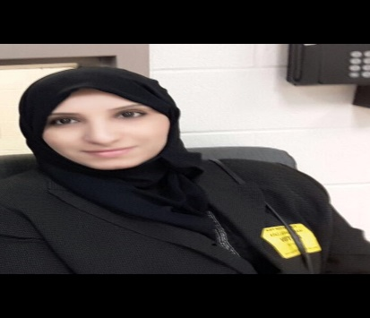

BY: Areej Alahahrani
Adviser: Dr, Shepherd William & Dr, Groves, Darrell
Clark Atlanta University
Dec 7, 2017

Description
Provides a variety of field- based experiences for education specialist and doctoral candidates over two semesters in divers’ settings at school districts, state education department or higher education. The field experience requires 300 contact hours including scheduled reflective seminars.

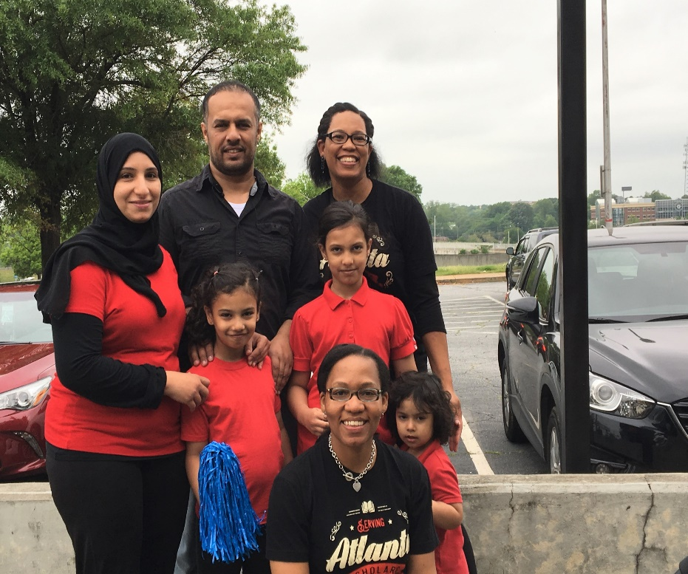
I did my advanced practicum of EDA 660 Spring 2017 in Kipp Way Academy elemertray school with Dr, singleton. This picture on toked on the Autism Speaks Walk August, 30th with Dr, singleton and her daughter, my husband Hadi and my daughters (Lamis, Tala, and Rose).

I did my advanced practicum of EDA 661 Fall 2017in Mays High School with Dr, Douglas Sanders. He is working as Assistant Principal of business & entrepreneurship.

